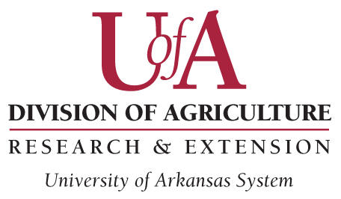Request for Modification – Spring 2024

Ag-IACUC Use Only
Protocol Number: Approval Date:

Instructions:
- This form is required for modifications (other than personnel) of an Animal Use Protocol (AUP) which is currently
- approved by the Ag-IACUC.
  - Major modifications that would significantly change either objectives or design will require a new AUP.
- In completing this modification request, please:
  - Explain the modification(s) so it can be clearly understood how it (or they) fit in the Experimental Design
as described in the AUP.
  - It is preferred that this document explain the proposed procedure(s) adequately so that the reviewers
do not need a copy of the AUP. However, if necessary refer to the AUP as needed so the reviewers can
clearly understand the proposed modification(s).
  - The deadline for getting this form to agiacuc@uark.edu is 12:00 midnight on the SECOND MONDAY
of every month.

Protocol #:

Project Title of Original Protocol:

Principal Investigator:

Objective of the Modification:

Requested Changes:

- Animals:
  - Change in Species:
  - Number of Animals required for this modification:

- Methods:
  - Change in Housing:
  - Change in Experimental Design:
  - Changes in Non-Surgical Procedures:
  - Changes in Surgical Procedures:
  - Changes in Euthanasia:
  - Other:

