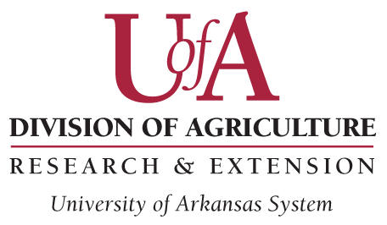Request to add Personnel

Ag-IACUC Use Only
Protocol Number: Approval Date:

Protocol #: Principal Investigator:

Instructions:
- This form is required for any personnel modifications of an Animal Use Protocol (AUP) which is currently approved
by the Ag-IACUC
- Please submit this form to agiacuc@uark.edu
Mandatory online training:
- All individuals with direct animal contact or animal responsibilities must take the following:
  - “Working with the IACUC” for Researchers, Animal Technicians, Research Administration/staff and Students working with animals (ANSC/POSC)

  - “Working with Poultry in Agricultural Research” (POSC)
    - To access the module: www.citiprogram.org

  - Poultry users must complete the POSC Departmental Training Videos and Quiz
    - Information and links for all required training can be found at: https://aaesbusinessoffice.uada.edu/agiacuc/forms

- All training will be verified. If training records cannot be found for any individual listed, the submission will not be considered until the training is complete.
- To add personnel, copy and paste Name/Experience/Euthanasia information beneath last addition.

Name:
Experience with species listed in AUP*? ☐ Yes ☐ No
Responsible for euthanasia within your Experimental Design: ☐ Yes ☐ No ☐ NA

*No individual should work unsupervised until deemed competent. All animal related training is the responsibility of the PI.

